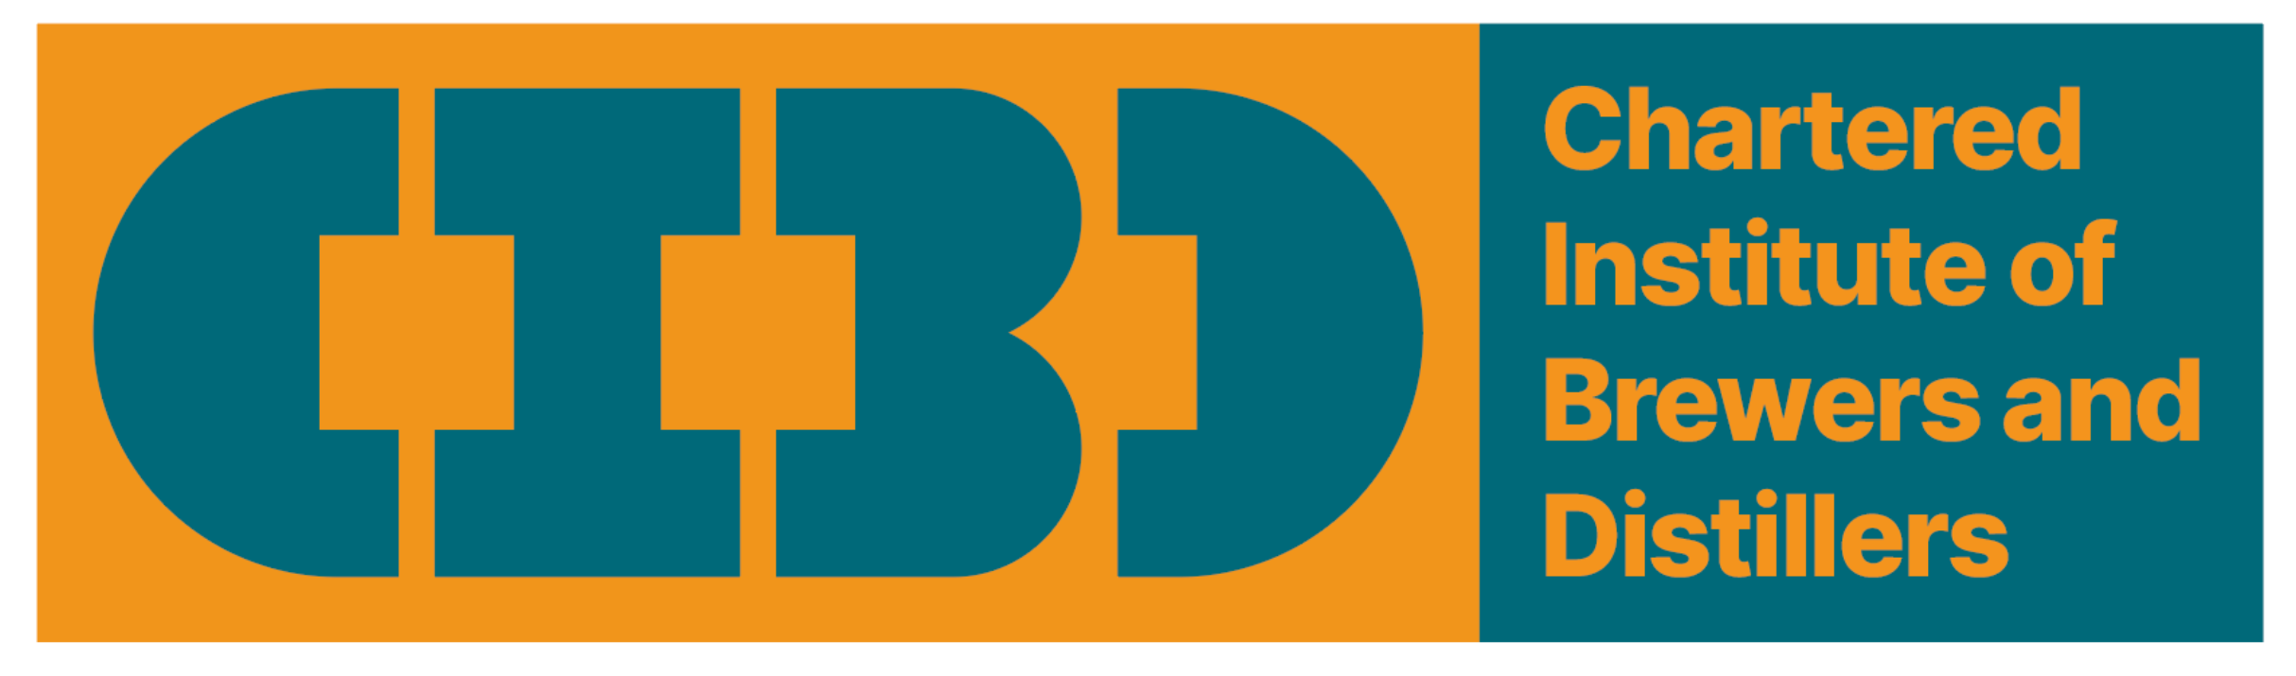

CIBD Grant Application Form
APPLICATION FOR GRANTS FROM THE CHARTERED INSTITUTE OF BREWERS AND DISTILLERS

All information will be treated as Confidential until a formal proposal has been made when the grant will become auditable as part of the CIBD legal and charitable requirements.

This application form should be completed and returned to the CIBD secretary of the section the application is made to.

PART A to be completed by Applicant
CIBD Section

Title of Project /Activity

Summary (Max 500 words)
Start Date
Project Duration (Months)
Total funding request
Total cost of Project/Activity
Applicant
Name
Address
Telephone
E-mail
CIBD membership number
Project /activity Director
Additional funding sources
Additional information
Return completed form to the section secretary
PART B to be completed by CIBD Section
Date received
Date approved/rejected
Applicant informed
Confirmation of application to Finance
Application unique number
Grant application type code
PART C to be completed by CIBD Finance Team
Date payment request received
Date payment made

